“Київський фаховий коледж зв’язку”

Циклова комісія Комп’ютерної та програмної інженерії

**ЗВІТ ПО ВИКОНАННЮ**

**ЛАБОРАТОРНОЇ РОБОТИ №2**

з дисципліни: «Операційні системи»

**Тема: “Знайомство з інтерфейсом та можливостями ОС Linux”**

Виконавли студенти

групи БІКС-03:

Румянцев Г.А.

Маламуж В.С.

Перевірив викладач

Сушанова В.С.

Київ 2022

**Мета роботи:**

1. Знайомство з інтерфейсами ОС Linux.

2. Отримання практичних навиків роботи в середовищах ОС Linux та мобільної ОС – їх графічною

оболонкою, входом і виходом з системи, ознайомлення зі структурою робочого столу, вивчення

основних дій та налаштувань при роботі в системі

**Матеріальне забезпечення занять**

1. ЕОМ типу IBM PC.

2. ОС сімейства Windows (Windows 7).

3. Віртуальна машина – Virtual Box (Oracle).

4. Операційна система GNU/Linux – CentOS.

5. Сайт мережевої академії Cisco netacad.com та його онлайн курси по Linux)

**Завдання для попередньої підготовки**

***Готував матеріал студент Румянцев Геннадій***

1. Прочитайте короткі теоретичні відомості до лабораторної роботи та зробіть невеличкий словник базових англійських термінів з питань класифікації ОС.

|  |  |
| --- | --- |
| **Термін англійською** | Термін українською |
| **Operating System** | Операційна система |
| **Server Applications** | Серверні програми |
| **The command line interface** | Інтерфейс командного рядка |
| **Traffic** | трафік |
| **Central processing unit (CPU)** | Центральний процессор |
| **Hardware** | обладнання |
| **The kernel** | Ядро |
| **Implementation** | Забезпечення, впровадження |

**4.** Define the following concepts:

- CLI mode

- Terminal based on graphical user interface

Command line interface (CLI) is a type of text interface between a person and a computer, in which instructions to the computer are given mainly by entering text strings (commands) from the keyboard, in UNIX systems it is possible to use a mouse.

Terminal based on graphical user interface is embodied by multi-window mode, changes in color, size, visibility (transparency, semi-transparency, invisibility) of windows, their location, sorting of window elements, flexible settings of both the windows themselves and their individual elements (files, folders, shortcuts, fonts, etc.), the availability of multi-user settings

**Tasks for preliminary preparation**

**The material was prepared by student Rumyantsev Gennady**

***Progress of work***

*Materials 1.1; 1.3 were prepared by student Rumyantsev Gennadiy*

*Materials 1.2; 2 prepared by student Malamuzh Volodymyr*

1.1.

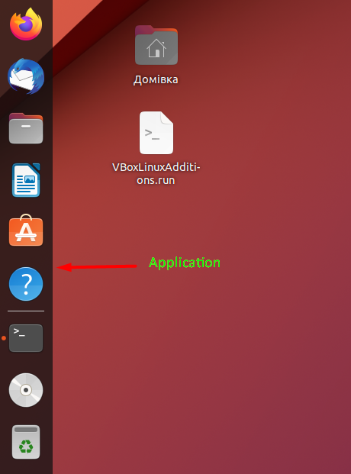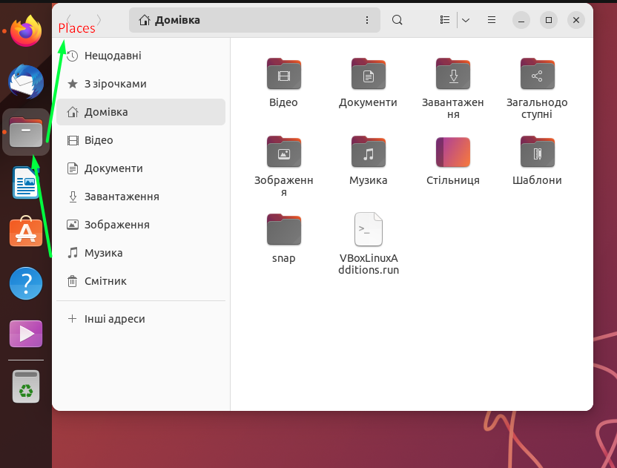

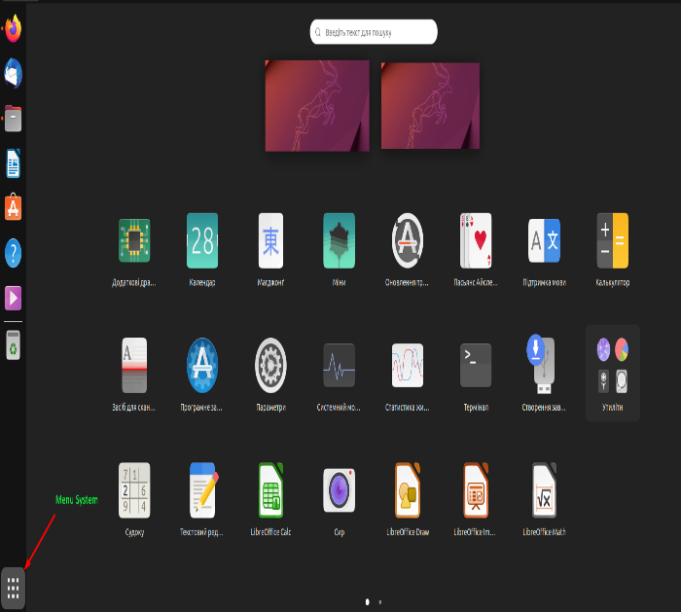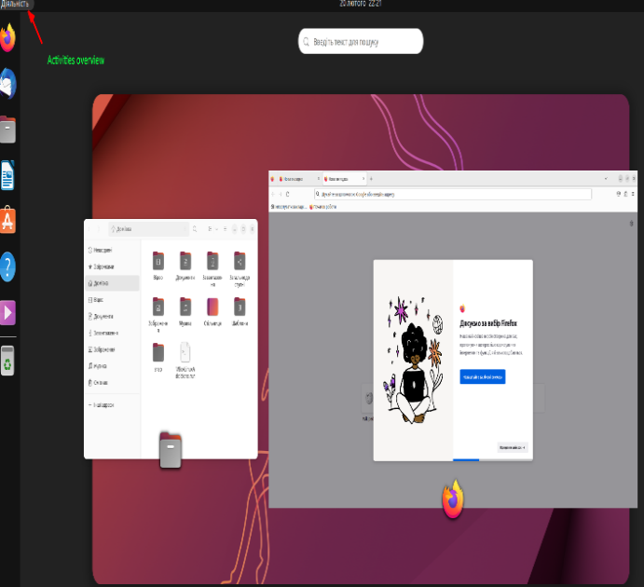

1.2. There are several ways to run programs in Linux:

* Using the command line
* Use the graphical user interface.
* Using hotkeys.
* Using the application menu.

1.3.

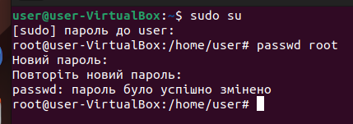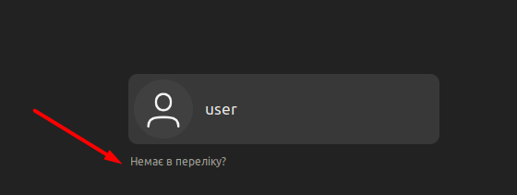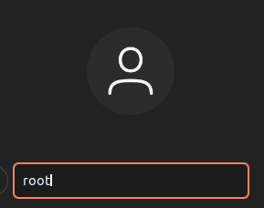

2)

2.1. The Android Home screen is the screen that appears after you unlock your device and displays app icons and shortcuts to your device's functions. the screen that appears after you unlock your device and displays app icons and shortcuts to your device's functions. The graphical interface that Android uses is called Material Design. It is characterized by bright colors, navigation tools, shadow effects, and ease of use.

2.2. Each mobile OS may differ in the appearance and content of the settings menu, but here are the main ones:

* General settings (phone language, date and time settings, Google device, and accounts)
* Network settings
* Display and brightness
* Sound and vibration
* Notifications and applications
* Device and data storage

2.3. Keyboard shortcuts on Android:

* Screen capture (volume button + power button)
* Open the "Recent actions" menu
* Perform a hard reset (press and hold the power and volume buttons)
* Perform a factory reset

Keyboard shortcuts may vary from phone to phone

2.4. To log in to Android, you need to enter your password or use your fingerprint on the lock screen.

Android has several different settings for managing battery power:

* Battery saver mode (disables or limits some features)
* No connection mode (disables all wireless connections)
* Normal mode (all functions work, no battery saving)

***Control questions:****Questions 1-5 were prepared by student Rumyantsev Gennadiy*

*Questions 6-10 were prepared by student Malamuzh Volodymyr*

1. The database server:

• MySQL is the most common open database that supports most programming languages.

• PostgreSQL - open relational database that offers more advanced functions and supports more complex requests.

• Mongodb is the NOSQL database that stores data in JSON format and can work with large data volumes.

2. Servers of posting messages:

• Postfix is a mail server that can send and receive electronic messages based on the SMTP protocol.

• Sendmail is another postal server that supports many protocols and is one of the most widely used mail servers.

• Exim is a mail server that supports various protocols and can work with a large number of users.

3. Files:

• Samba - allows Linux users to exchange files with Windows users in one local network.

• VSFTPD is a FTP server that allows users to exchange files with remote servers on the FTP protocol.

• PROFTPD is another open source FTP server that can be used to exchange files between remote servers.

2. Each of the shells (Bourne, C, Bash, TCSH, KSH and ZSH) has its own characteristics. Bourne Shell (SH) is one of the oldest UNIX shell and is used in many script programming scenarios. Cell (CSH) has convenient functions, such as the history of commands and auto -filling, but can be less intuitive and more prone to errors. The Bourne Again Shell (Bash) is one of the most common Linux shells, which includes most of the SH and CSH functions, and also has many additional opportunities that make the programming of scripts more convenient. Tenex C Shell (TCSH) is based on CSH and has more convenient functions, such as improved auto -filling and color backlighting. Korn Shell (KSH) is based on SH, but has many capabilities from CSH and Bash, making programming scripts more convenient and understandable. Z Shell (ZSH) supports many functions from Bash and has many own capabilities, making it the most advanced shell, but can be less intuitive to some users

3. Linux has several packages managers, for example: Apt, Yum, Pacman, Portage, ZyPper, Snap and Flatpak. Each of them is intended for use in specific distributions of Linux, has its own characteristics and is able to control packages of various formats (for example, .deb, .rpm and .Snap

4. Linux is a safe and reliable operating system with a wide set of security mechanisms. Some of them include:

1) Access for monitoring access to files and catalogs.

2) Selinux - a set of security mechanisms to manage access to system resources and control of user and process actions.

3) Apparmor - security mechanism to limit the access of applications to system resources and monitoring the actions of processes.

4) IPTABles Firewall to configure safety rules for blocking or resolving access to network ports and addresses.

5) Antivirus software to protect the system from malicious programs.

6) Shifting disk and file systems to protect confidential data.

7) Safety renovation updates to correct vulnerabilities in the nucleus, applications and libraries.

In general, Linux is an excellent choice for critical systems due to its security mechanisms and reliability

5.The use of virtualization is relevant for several reasons:

1) Savings of resources: the ability to launch several virtual machines on one server allows you to save resources and reduce the number of physical servers. 2) Management and scaling: virtualization simplifies the management and scaling of server infrastructure, allowing you to easily add, remove or scale virtual machines depending on the load. 3) Isolation: virtualization allows you to isolate each virtual machine from others, increasing safety and reducing the risks of system disruption. 4) Testing and development: Virtualization simplifies the testing and development of software, allowing you to create virtual environments for testing and development without the need to have physical servers. 5) Reserve and recovery: virtualization allows you to easily create backups and restore systems in case of failures or errors, ensuring the reliability and safety of data. 6) Mobility: the ability to move virtual machines between physical servers or clouds provides mobility and flexibility of working with the system.

As a result, the use of virtualization provides economic, technical and functional advantages that help reduce the costs of IT infrastructure, increase the safety and reliability of the system, as well as simplify the management and scaling of server infrastructure

6. Containerization is a technology that allows you to pack and run applications in containers that are equipped with everything you need to run the program.

7. Open source software allows you to view or modify the program code. Such programs are easier to find and fix bugs, usually free of charge, and convenient for your own use through modification. Among the disadvantages are the lack of guarantees and support from the vendor, lack of income (except for charitable donations), security problems.

8. Linux usually has 6 active virtual consoles by default. They can be opened using the hotkeys "Ctrl + Alt + F1" to "Ctrl + Alt + F7". Examples of active virtual consoles in Linux:

* GNOME Terminal
* Konsole
* Terminator
* Tmux
* Screen

9. In most Linux distributions, the graphical shell runs on the virtual console numbered 7. This console usually contains a graphical display manager that provides access to a graphical shell such as GNOME, KDE, XFCE, etc.

10. In Linux, you can create multiple accounts with the same system name (username) but different user IDs. The main advantage is that they can have different access rights to files and directories that belong to them, regardless of the access rights to files and directories belonging to other accounts with the same name. But using multiple accounts with the same name can lead to confusion and complicate system management